**Assignment 2.6**

Introduction: This is a Acadgild big data session assignment number 2.6 where we have to perform pig latin operation on Pokémon data which is available as follow link.

(<https://drive.google.com/file/d/0ByJLBTmJojjzZTJQM2UzN2J6aUU/view>)

Lets download this data in your local system and give it name as pokeman.csv. First of all we load data in pig grunt shell by using following command.



After loading a data in pig we will perform following data analysis operation on this loaded data and the input for this above loaded data in our case relation name is Pokémon data is as follow.

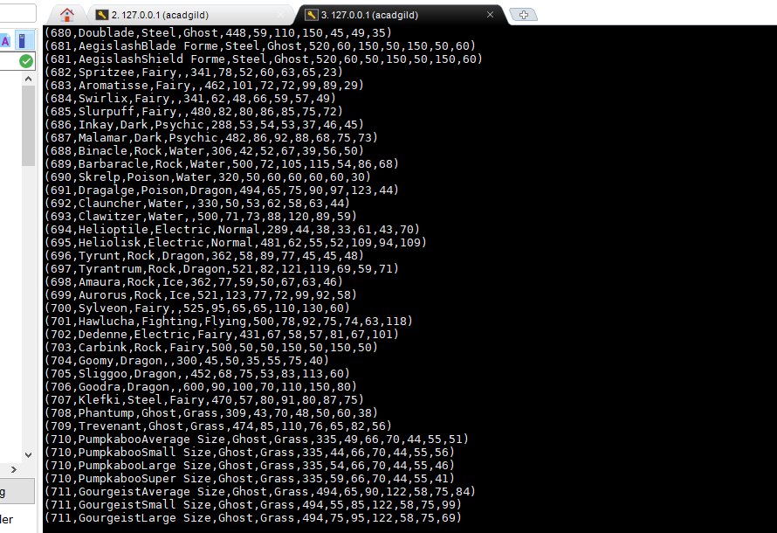

Now it is time to perform some analysis on this data as follow.

**Ques 1: Find the list of players that have been selected in the qualifying round (DEFENCE>55).**

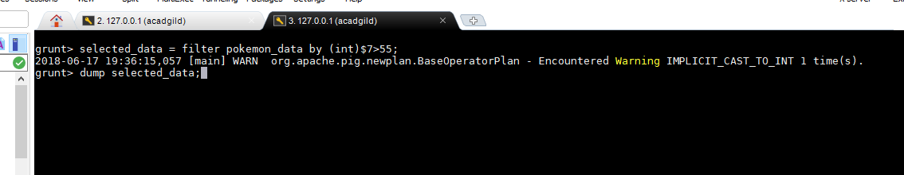

After applying filter operation we get eligible data which is selected in qualifying round. The output for this data is as follow.

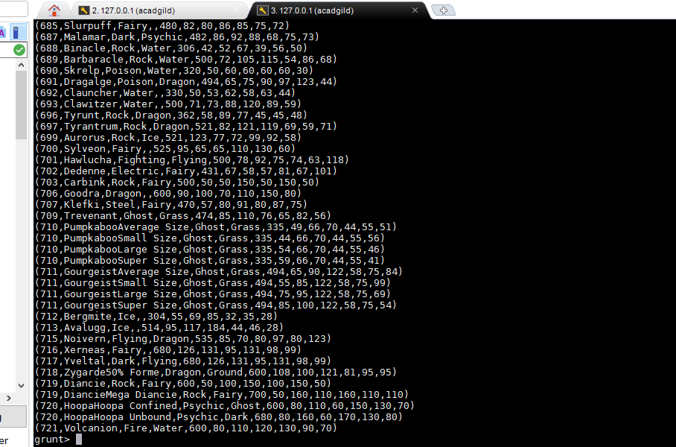

#### Ques 2: State the number of players taking part in the competition after getting selected in the qualifying round.

#### The following command find the number of player taking part in the competition after getting selected in qualifying round which is in our case defense should greater than 55.

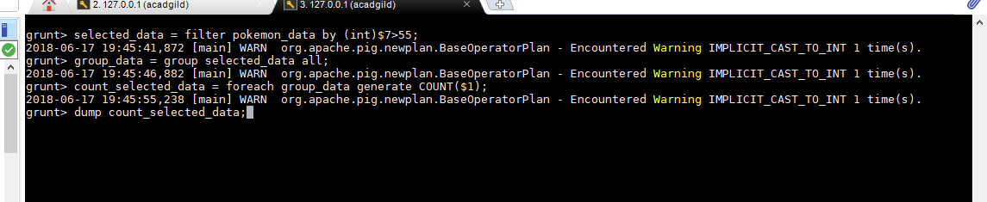

#### This will produce following output.

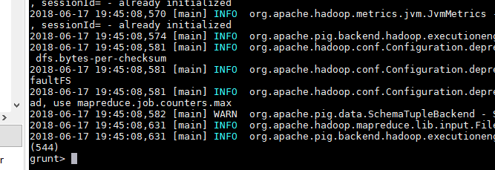

#### That mean number of qualifying candidate is 544.

#### Ques 3: Using random () generate random numbers for each Pokémon on the selected list.

#### To find the random number for each Pokémon on selected list we use following command.

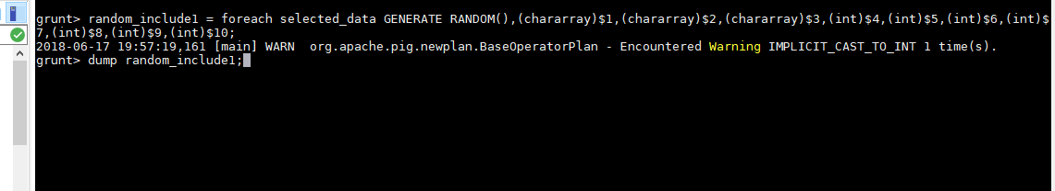

#### Output will be as follow..

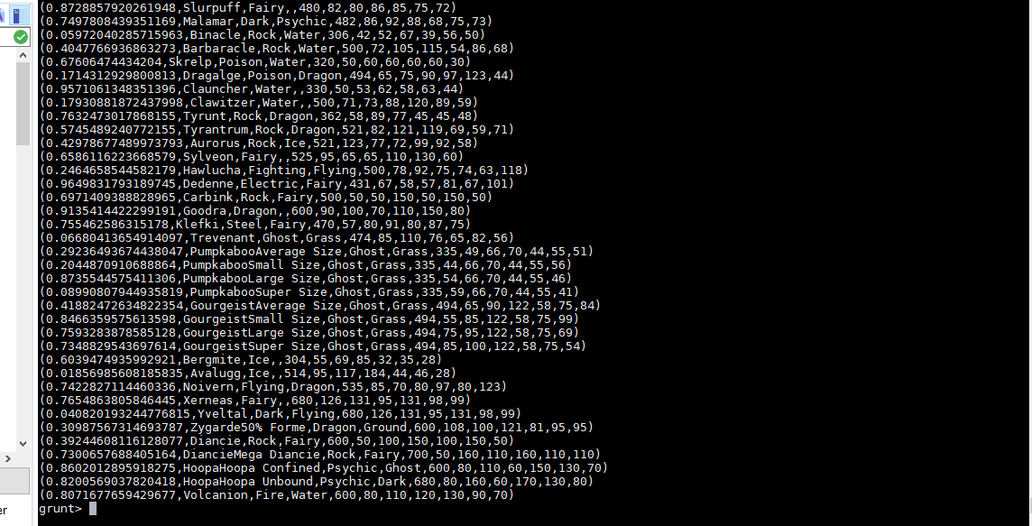

#### Ques 4: Arrange the new list in a descending order according to a column randomly.

#### The command as follow

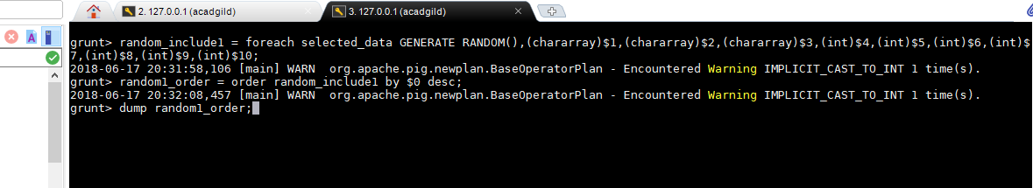

#### The output is as follow.

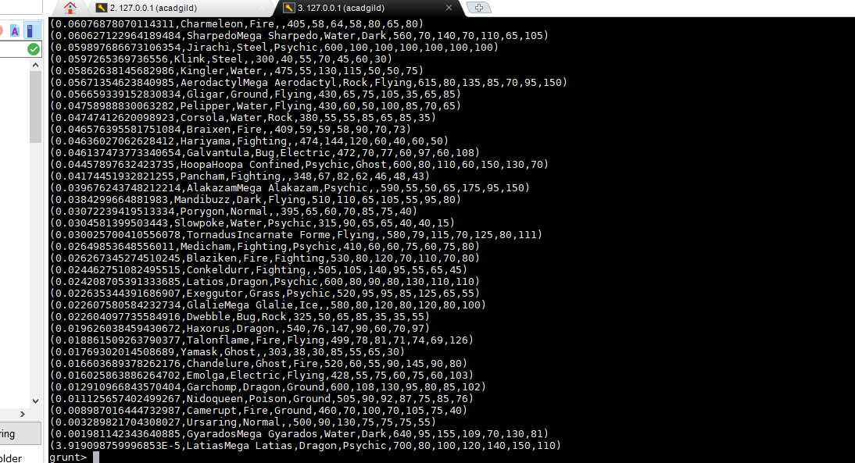

#### Ques 5: Now on a new relation again associate random numbers for each Pokémon and arrange in descending order according to column random.

#### The command is as follow.

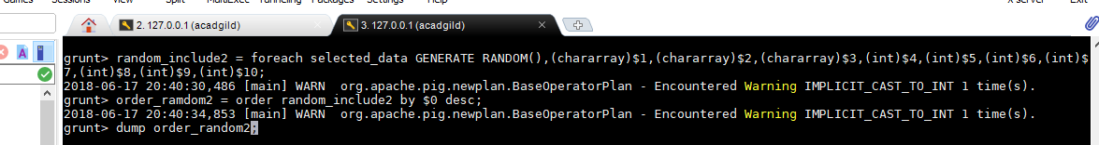

#### The output for second random is as follow.

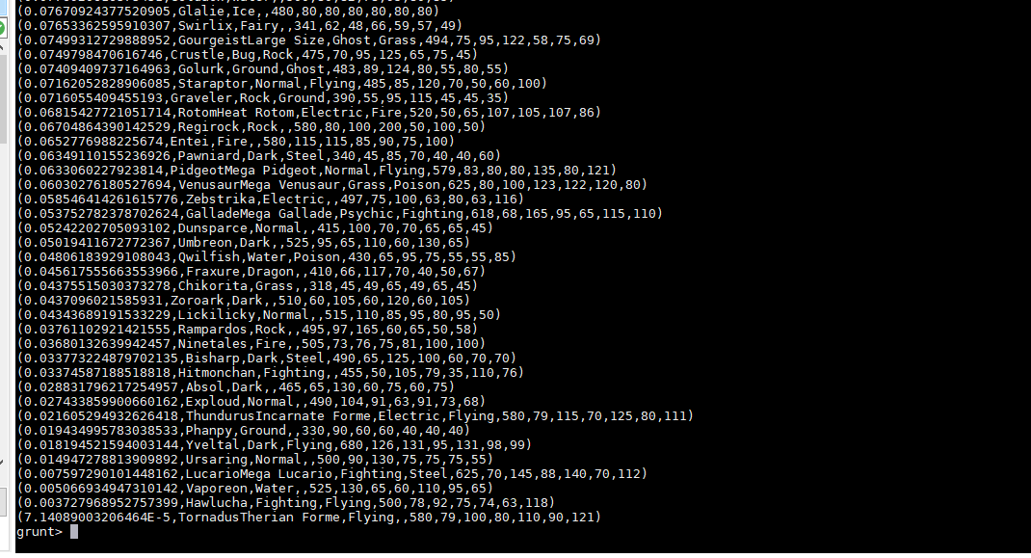

#### Ques: From the two different descending lists of random Pokémons, select the top 5 Pokémons for 2 different players.

#### For this question we first need to find a top 5 pokeman from random_include1 relation by using limit operator by using following command as shown below.



#### And we will get the top 5 Pokémon in random_include1 as follow.

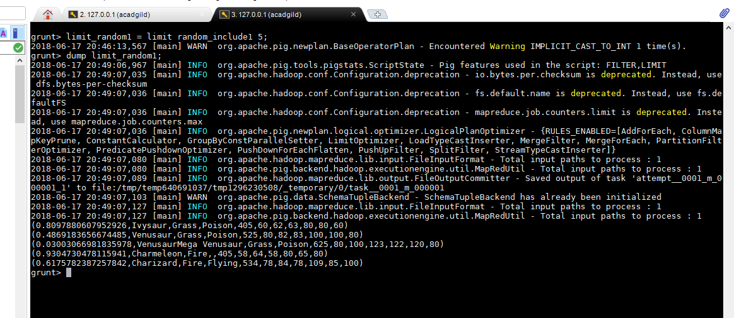

#### Now for the random 2 we follow the same method as we follow while finding a top five pokeman playes among a data .

#### 

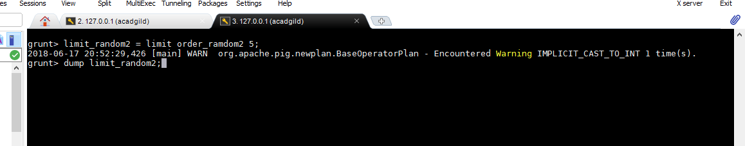

#### The output will be like this.

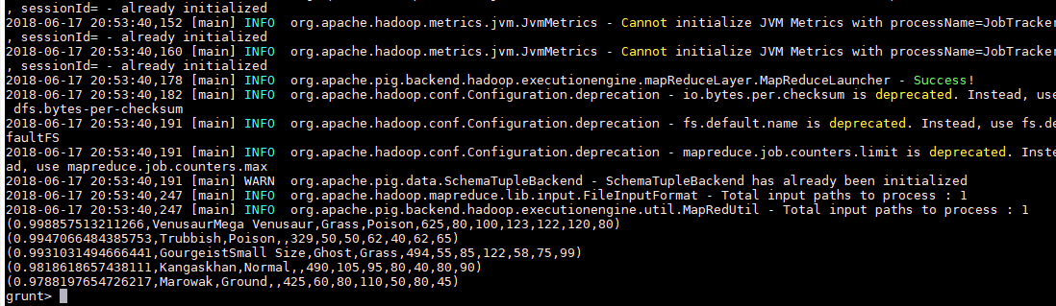

#### Quest: Store the data on a local drive to announce for the final match. By the name player1 and player2 (only show the NAME and HP).

#### To store the above limit data we should use store command

#### Here,let save limit_random1 as a player1 and limit_random2 as a player2. Now execute following command to store your respective data on your local machine.

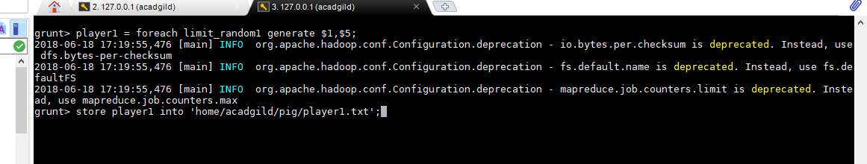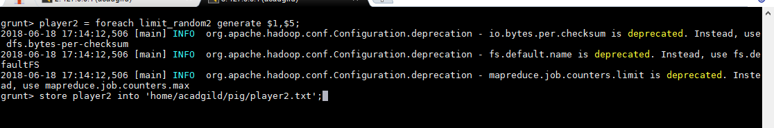

After storing data it will give success message that saying where you have store data. In my case following success repor come for both player1 and player2 as follow.

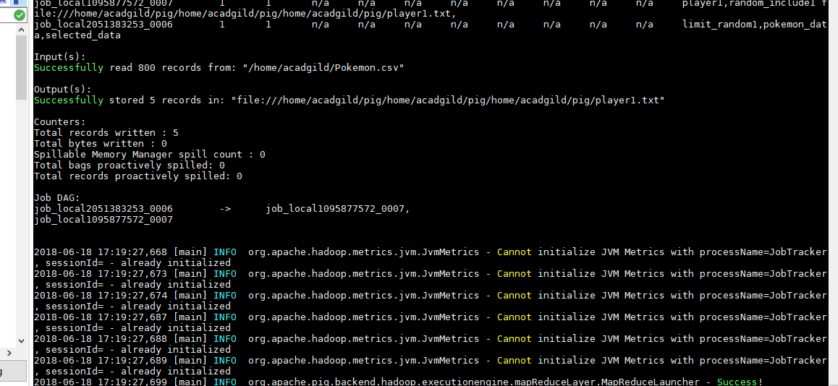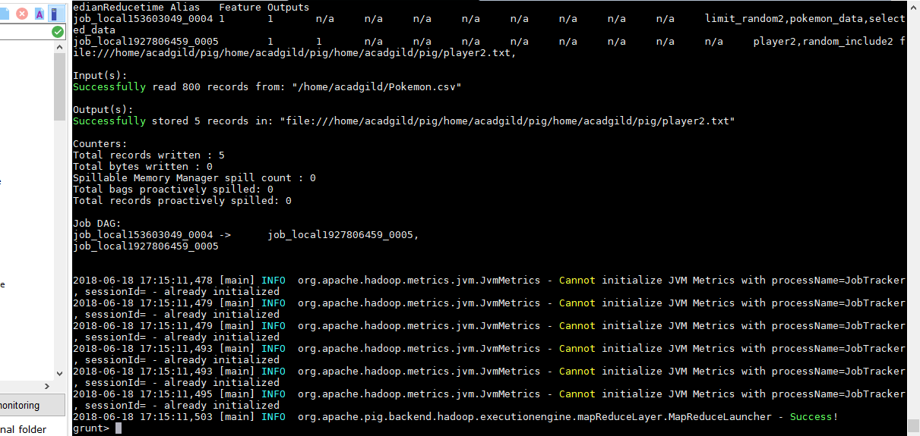

***--THE END--***